IBM ASSIGNMENT – 1

(SUBMITTED BY: THIYAGARAJAN M)

Circuit with Piezo alarm, PIR sensor, Temperature sensor with below functionalities:

1. Alarm sound if temperature is above 60℃.
2. Alarm sound with different frequency if motion is detected in PIR sensor.

CIRCUIT:

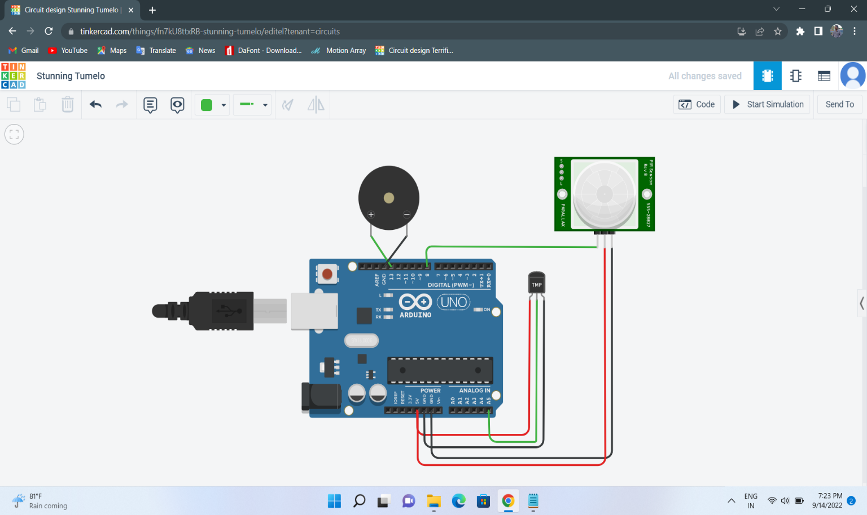

CODE:

void setup()

{

Serial.begin(9600);

pinMode(8, INPUT);

pinMode(13, OUTPUT);

}

void loop()

{

int m=digitalRead(8);

if(m==1)

{

Serial.println("MOTION DETECTED");

}

else

{

Serial.println("NO MOTION DETECTED");

}

double d=analogRead(A5);

double n=d/1024;

double volt=n\*5;

double off=volt-0.5;

double temp=off\*100;

Serial.print("The Temperature is : ");

Serial.println(temp);

if(m==1)

{

tone(13,1000);

delay(1000);

}

else if(temp>60)

{

tone(13,200);

delay(1000);

}

else

{

noTone(13);

delay(1000);

}

}

OUTPUT:

